2.1 Counting
Remember that for a finite sample space S with equally likely outcomes, the probability of an event A is given by

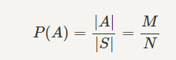

Thus, finding probability of A reduces to a counting problem in which we need to count how many elements are in A and S. In this section, we will discuss ways to count the number of elements in a set in an efficient manner. Counting is an area of its own and there are books on this subject alone. Here we provide a basic introduction to the material that is usually needed in probability. Almost everything that we need about counting is the result of the multiplication principle. We previously saw the multiplication principle when we were talking about Cartesian products. Here we look at it from a different perspective. Let us look at a simple example.

Example
Suppose that I want to purchase a tablet computer. I can choose either a large or a small screen; a 64GB, 128GB, or 256GB storage capacity, and a black or white cover. How many different options do I have?

----------------------------------------------------------------------------------Here are the options:
    - L-64-B
    - L-64-W
    - L-128-B
    - L-128-W
    - L-256-B
    - L-256-W
    - S-64-B
    - S-64-W
    - S-128-B
    - S-128-W
    - S-256-B
    - S-256-W

Thus, there are 1212 possible options. The multiplication principle states that we can simply multiply the number of options in each category (screen size, memory, color) to get the total number of possibilities, i.e., the answer is 2×3×2=122×3×2=12.
----------------------------------------------------------------------------------
Here is a formal statement of the multiplication principle.
Multiplication Principle
Suppose that we perform r experiments such that the kth experiment has nk possible outcomes, for k=1,2,⋯⋯,r. Then there are a total of n1×n2×n3×⋯×nr possible outcomes for the sequence of r experiments.

--------------------------------------------------------------------------------------------------------------------------------------

Example
I need to choose a password for a computer account. The rule is that the password must consist of two lowercase letters (a to z) followed by one capital letter (A to Z) followed by four digits (0,1,⋯,90,1,⋯,9). For example, the following is a valid password

ejT3018

- find the total number of possible passwords, N.
- A hacker has been able to write a program that randomly and independently generates 108108 passwords according to the above rule. Note that the same password could be generated more than once. If one of the randomly chosen passwords matches my password, then he can access my account information. What is the probability that he is successful in accessing my account information?

--------------------------------------------------------------------------------------------------------------------------------------

To choose a password, I need to first choose a lowercase letter, then another lowercase letter, then one capital letter, and then 44 digits. There are 2626 lowercase letters, 2626 capital letters, and 1010 digits. Thus, by the multiplication principle, the total number of possible valid passwords is
N=26×26×26×10×10×10×10=263×104
Let Gi denote the event that the hacker's ith guess matches mine, for i=1,2,⋯,108. The probability that the ith randomly chosen password matches mine is

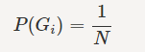

Now let phack be the probability that the hacker is successful, that is at least one of the randomly chosen passwords matches mine. Recall that "at least" means union:

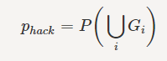

Note that the events Gi are independent since the guesses are independently generated, but they are not disjoint since multiple guesses could be correct if the hacker's program generates the same password. Therefore in this case it is easier to work with intersections than unions, so we will find the probability of the complement event first:

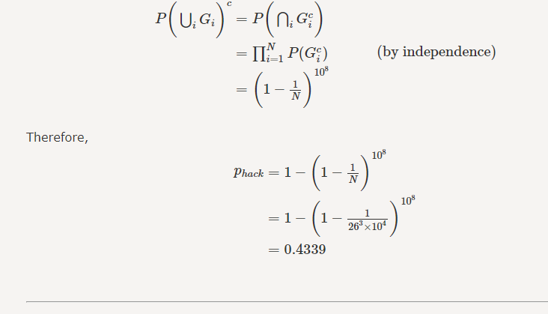
--------------------------------------------------------------------------------------------------------------------------------------

--------------------------------------------------------------------------------------------------------------------------------------

Example
Let A be a set with |A|=n<∞How many distinct subsets does A have?

--------------------------------------------------------------------------------------------------------------------------------------

- Let's assume A={a1,a2,a3,⋯,an}We can look at this problem in the following way. To choose a subset B, we perform the following experiment. First we decide whether or not a1∈B (two choices), then we decide whether or not a2∈B (two choices), then we decide whether or not a3∈B (two choices), ..., and finally we decide whether or not an∈B (two choices). By the multiplication principle, the total number of subsets is then given by 2×2×2×⋯×2=2n. To check our answer, let's assume A={1,2}.Then our formula states that there are 44 possible subsets. Indeed, the subsets are
  - {}=∅{}=∅
  - {1}{1}
  - {2}{2}
  - {1,2}
--------------------------------------------------------------------------------------------------------------------------------------
Here, we would like to provide some general terminology for the counting problems that show up in probability to make sure that the language that we use is precise and clear.
- Sampling: sampling from a set means choosing an element from that set. We often draw a sample at random from a given set in which each element of the set has equal chance of being chosen.

- With or without replacement: usually we draw multiple samples from a set. If we put each object back after each draw, we call this sampling with replacement. In this case a single object can be possibly chosen multiple times. For example, if A={a1,a2,a3,a4} and we pick 3 elements with replacement, a possible choice might be (a3,a1,a3). Thus "with replacement" means "repetition is allowed." On the other hand, if repetition is not allowed, we call it sampling without replacement.

- Ordered or unordered: If ordering matters (i.e.: a1,a2,a3≠a2,a3,a1), this is called ordered sampling. Otherwise, it is called unordered.
Thus when we talk about sampling from sets, we can talk about four possibilities.
- ordered sampling with replacement
- ordered sampling without replacement
- unordered sampling without replacement
- unordered sampling with replacement
We will discuss each of these in detail and indeed will provide a formula for each. The formulas will be summarized at the end in Table 2.1. Nevertheless, the best approach here is to understand how to derive these formulas. You do not actually need to memorize them if you understand the way they are obtained.

2.1.1 Ordered Sampling with Replacement
Here we have a set with n elements (e.g.: A={1,2,3,⋯.n}and we want to draw k samples from the set such that ordering matters and repetition is allowed. For example, if A={1,2,3}and k=2, there are 99 different possibilities:
- (1,1);
- (1,2);
- (1,3);
- (2,1);
- (2,2);
- (2,3);
- (3,1);
- (3,2);
- (3,3).
In general, we can argue that there are k positions in the chosen list: ((Position 1, Position 2, ..., Position k). There are n options for each position. Thus, when ordering matters and repetition is allowed, the total number of ways to choose k objects from a set with n elements is
n×n×...×n=n^k
Note that this is a special case of the multiplication principle where there are k "experiments" and each experiment has n possible outcomes.

2.1.2 Ordered Sampling without Replacement:
Permutations
Consider the same setting as above, but now repetition is not allowed. For example, if A={1,2,3} and k=2, there are 6 different possibilities:
- (1,2);
- (1,3);
- (2,1);
- (2,3);
- (3,1);
- (3,2).
In general, we can argue that there are k positions in the chosen list: ((Position 1, Position 2, ..., Position k)). There are n options for the first position, (n−1) options for the second position (since one element has already been allocated to the first position and cannot be chosen here), (n−2) options for the third position, ... (n−k+1) options for the kth position. Thus, when ordering matters and repetition is not allowed, the total number of ways to choose k objects from a set with n elements is
n×(n−1)×...×(n−k+1).
Any of the chosen lists in the above setting (choose k elements, ordered and no repetition) is called a k-permutation of the elements in set A. We use the following notation to show the number of k-permutations of an n-element set:
Pnk=n×(n−1)×...×(n−k+1).
Note that if k is larger than n, then Pnk=0. This makes sense, since if k>n there is no way to choose k distinct elements from an n-element set. Let's look at a very famous problem, called the birthday problem, or the birthday paradox.

Example
If k people are at a party, what is the probability that at least two of them have the same birthday? Suppose that there are n=365 days in a year and all days are equally likely to be the birthday of a specific person.

Let A be the event that at least two people have the same birthday. First note that if k>n, then P(A)=1; so, let's focus on the more interesting case where k≤n. Again, the phrase "at least" suggests that it might be easier to find the probability of the complement event, P(Ac). This is the event that no two people have the same birthday, and we have

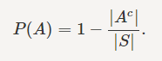
Thus, to solve the problem it suffices to find |A^c| and |S|. Let's first find |S|. What is the total number of possible sequences of birthdays of k people? Well, there are n=365 choices for the first person, n=365 choices for the second person,... n=365 choices for the kth person. Thus there are

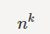
possibilities. This is, in fact, an ordered sampling with replacement problem, and as we have discussed, the answer should be nk (here we draw k samples, birthdays, from the set {1,2,...,n=365}). Now let's find |Ac|. If no birthdays are the same, this is similar to finding |S| with the difference that repetition is not allowed, so we have
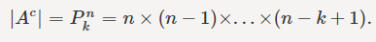

You can see this directly by noting that there are n=365 choices for the first person, n−1=364 choices for the second person,..., n−k+1 choices for the kth person. Thus the probability of A can be found as

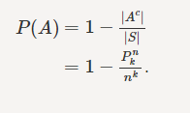

Discussion: The reason this is called a paradox is that P(A) is numerically different from what most people expect. For example, if there are k=2323 people in the party, what do you guess is the probability that at least two of them have the same birthday, P(A)? The answer is .5073.5073, which is much higher than what most people guess. The probability crosses 9999 percent when the number of peoples reaches 5757. But why is the probability higher than what we expect?
It is important to note that in the birthday problem, neither of the two people are chosen beforehand. To better answer this question, let us look at a different problem: I am in a party with k−1 people. What is the probability that at least one person in the party has the same birthday as mine? Well, we need to choose the birthdays of k−1 people, the total number of ways to do this is nk−1. The total number of ways to choose the birthdays so that no one has my birthday is (n−1)k−1. Thus, the probability that at least one person has the same birthday as mine is

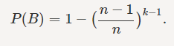

Now, if k=23, this probability is only P(B)=0.0586, which is much smaller than the corresponding P(A)=0.5073. The reason is that event B is looking only at the case where one person in the party has the same birthday as me. This is a much smaller event than event A which looks at all possible pairs of people. Thus, P(A) is much larger than P(B). We might guess that the value of P(A) is much lower than it actually is, because we might confuse it with P(B).
Permutations of n� elements: An n-permutation of n elements is just called a permutation of those elements. In this case, k=n and we have

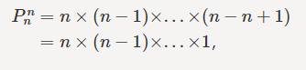

which is denoted by n!, pronounced "n factorial". Thus n! is simply the total number of permutations of n elements, i.e., the total number of ways you can order n different objects. To make our formulas consistent, we define 0!=10!=1.

Example
Shuffle a deck of 52 cards. How many outcomes are possible? (In other words, how many different ways can you order 52 distinct cards? How many different permutations of 52 distinct cards exist?) The answer is 52!.

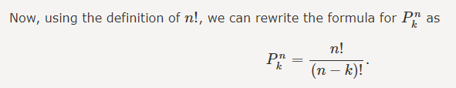

The number of k-permutations of n distinguishable objects is given by

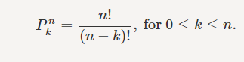

Note: There are several different common notations that are used to show the number of k-permutations of an n-element set including Pn,k,P(n,k),nPk, etc. In this book, we always use Pnk.

2.1.3 Unordered Sampling without Replacement:
Combinations
Here we have a set with n elements, e.g., A={1,2,3,....n} and we want to draw k samples from the set such that ordering does not matter and repetition is not allowed. Thus, we basically want to choose a k-element subset of A, which we also call a k-combination of the set A. For example if A={1,2,3} and k=2, there are 33 different possibilities:
- {1,2};
- {1,3};
- {2,3}.
We show the number of k-element subsets of A by

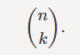

This is read "n choose k." A typical scenario here is that we have a group of n people, and we would like to choose k of them to serve on a committee. A simple way to find (nk) is to compare it with Pnk. Note that the difference between the two is ordering. In fact, for any k-element subset of A={1,2,3,....n}, we can order the elements in k! ways, thus we can write
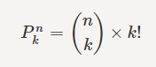

Therefore,

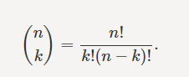

Note that if k is an integer larger than n, then (nk)=0. This makes sense, since if k>n there is no way to choose k distinct elements from an n-element set.

The number of k-combinations of an n-element set is given by
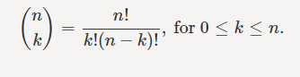

nk) is also called the binomial coefficient. This is because the coefficients in the binomial theorem are given by (nk)(��). In particular, the binomial theorem states that for an integer n≥0, we have

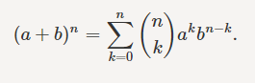

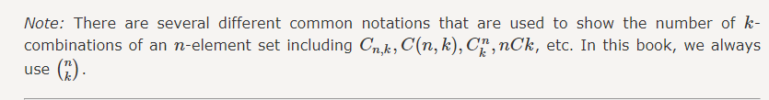

Example
I choose 33 cards from the standard deck of cards. What is the probability that these cards contain at least one ace?

Again the phrase "at least" suggests that it might be easier to first find P(A^c), the probability that there is no ace. Here the sample space contains all possible ways to choose 33 cards from 5252 cards, thus

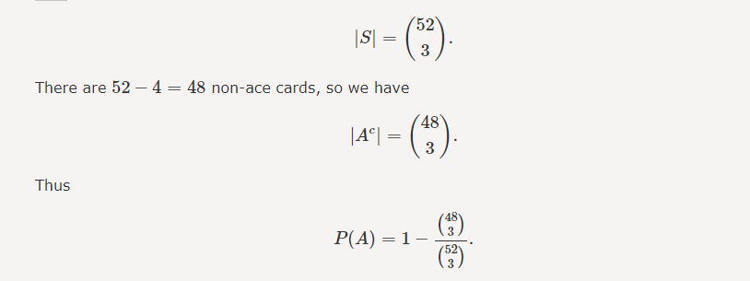

Example
How many distinct sequences can we make using 3 letter "A"s and 5 letter "B"s? (AAABBBBB, AABABBBB, etc.)

you can think of this problem in the following way. You have 3+5=8 positions to fill with letters A or B. From these 8 positions, you need to choose 3 of them for As. Whatever is left will be filled with Bs. Thus the total number of ways is

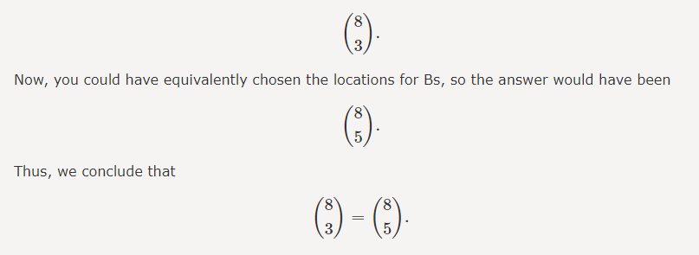

the same argument can be repeated for general n and k to conclude
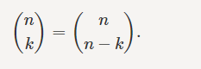

You can check this identity directly algebraically, but the way we showed it here is interesting in the sense that you do not need any algebra. This is sometimes a very effective way of proving some identities of binomial coefficients. This is proof by combinatorial interpretation. The basic idea is that you count the same thing twice, each time using a different method and then conclude that the resulting formulas must be equal. Let us look at some other examples.

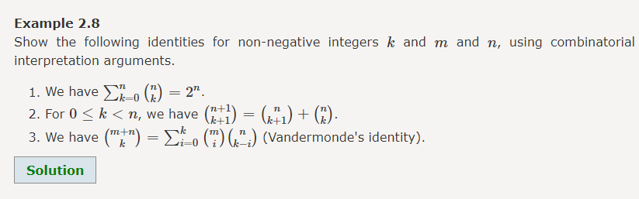

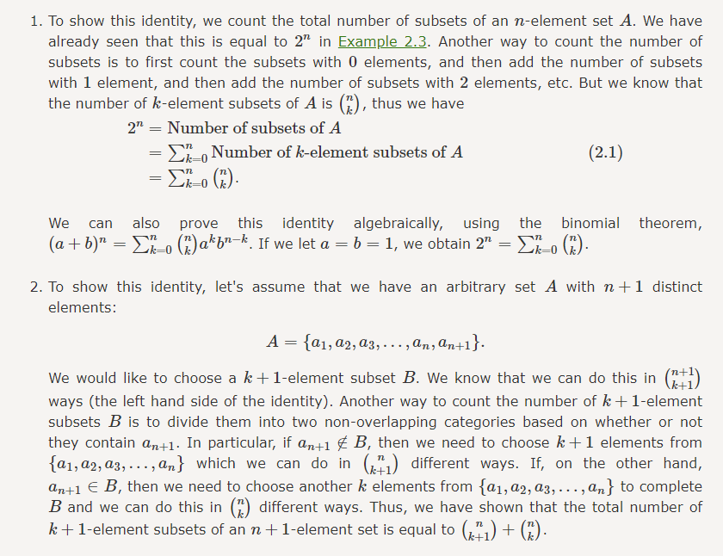
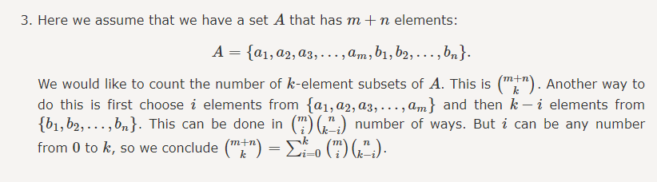
Let us now provide another interpretation of (nk). Suppose that we have a group of n people and we would like to divide them into two groups A and B such that group A consists of k people and group B consists of n−k people. To do this, we just simply need to choose k people and put them in group A, and whoever is left will be in group B. Thus, the total number of ways to do this is (nk).
The total number of ways to divide n distinct objects into two groups A and B such that group A consists of k objects and group B consists of n−k objects is (nk).

Note: For the special case when n=2k and we do not particularly care about group names A and B, the number of ways to do this division is 12(nk) to avoid double counting. For example, if 22 players want to play a soccer game and we need to divide them into two groups of 11 players, there will be 12(2211) ways to do this. The reason for this is that, if we label the players 1 to 22, then the two choices

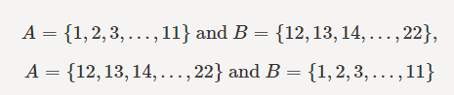

are essentially the same.
For example, we can solve Example 2.7 in the following way: We have 88 blank positions to be filled with letters "A" or "B." We need to divide them into two groups A and B such that group A consists of three blank positions and group B consists of 5 blank spaces. The elements in group A show the positions of "A"s and the elements in group B show the positions of "B"s. Therefore the total number of possibilities is (83).

Bernoulli Trials and Binomial Distribution:
Now, we are ready to discuss an important class of random experiments that appear frequently in practice. First, we define Bernoulli trials and then discuss the binomial distribution. A Bernoulli Trial is a random experiment that has two possible outcomes which we can label as "success" and "failure," such as
- You toss a coin. The possible outcomes are "heads" and "tails." You can define "heads" as success and "tails" as "failure" here.
- You take a pass-fail test. The possible outcomes are "pass" and "fail."
We usually denote the probability of success by p and probability of failure by q=1−p. If we have an experiment in which we perform n independent Bernoulli trials and count the total number of successes, we call it a binomial experiment. For example, you may toss a coin n times repeatedly and be interested in the total number of heads.

Example
Suppose that I have a coin for which P(H)=p and P(T)=1−p. I toss the coin 5 times.
- What is the probability that the outcome is THHHH?
- What is the probability that the outcome is HTHHH?
- What is the probability that the outcome is HHTHH?
- What is the probability that I will observe exactly four heads and one tails?
- What is the probability that I will observe exactly three heads and two tails?
- If I toss the coin n times, what is the probability that I observe exactly k heads and n−k tails?
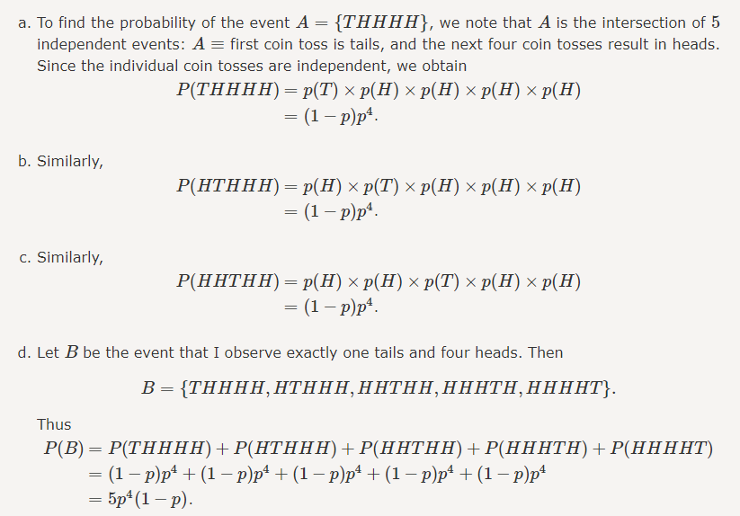

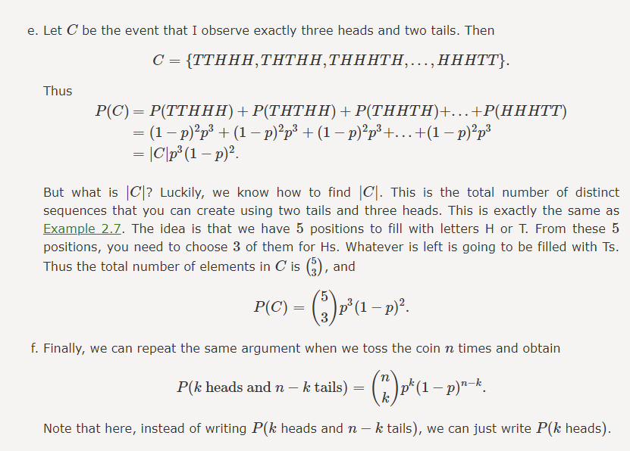

Binomial Formula:
For n independent Bernoulli trials where each trial has success probability p, the probability of k successes is given by

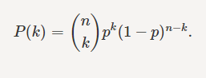

Multinomial Coefficients:
The interpretation of the binomial coefficient (nk) as the number of ways to divide n objects into two groups of size k and n−k has the advantage of being generalizable to dividing objects into more than two groups.

Example
Ten people have a potluck. Five people will be selected to bring a main dish, three people will bring drinks, and two people will bring dessert. How many ways can they be divided into these three groups?

We can solve this problem in the following way. First, we can choose 55 people for the main dish. This can be done in (105)(105) ways. From the remaining 55 people, we then choose 33 people for drinks, and finally the remaining 22 people will bring desert. Thus, by the multiplication principle, the total number of ways is given by

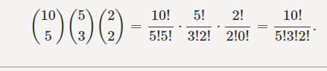
This argument can be generalized for the case when we have n people and would like to divide them to r groups. The number of ways in this case is given by the multinomial coefficients. In particular, if n=n1+n2+...+nr, where all ni≥0 are integers, then the number of ways to divide n distinct objects to r distinct groups of sizes n1,n2,...,nr is given by
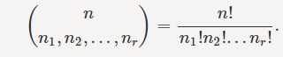

We can also state the general format of the binomial theorem, which is called the multinomial theorem:
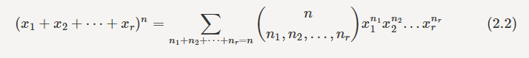
Finally, the binomial formula for Bernoulli trials can also be extended to the case where each trial has more than two possible outcomes.

Example
I roll a die 1818 times. What is the probability that each number appears exactly 33 times?

First of all, each sequence of outcomes in which each number appears 33 times has probability

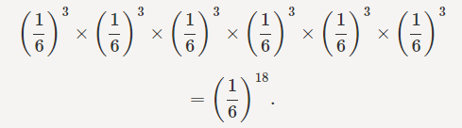
How many distinct sequences are there with three 11's, three 22's, ..., and three 66's? Each sequence has 1818 positions which we need to fill with the digits. To obtain a sequence, we need to choose three positions for 11's, three positions for 22's, ..., and three positions for 66's. The number of ways to do this is given by the multinomial coefficient

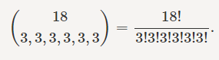

Thus the total probability is

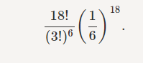
We now state the general form of the multinomial formula. Suppose that an experiment has r possible outcomes, so the sample space is given by
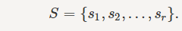
Also suppose that P(si)=pi for i=1,2,...,r. Then for n=n1+n2+...+nr independent trials of this experiment, the probability that each si appears ni times is given by

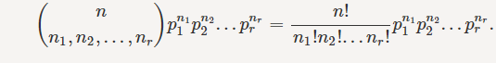

2.1.4 Unordered Sampling with Replacement
Among the four possibilities we listed for ordered/unordered sampling with/without replacement, unordered sampling with replacement is the most challenging one. Suppose that we want to sample from the set A={a1,a2,...,an}�={�1,�2,...,��} k� times such that repetition is allowed and ordering does not matter. For example, if A={1,2,3}�={1,2,3} and k=2�=2, then there are 66 different ways of doing this

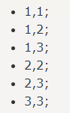

How can we get the number 66 without actually listing all the possibilities? One way to think about this is to note that any of the pairs in the above list can be represented by the number of 11's, 22's and 33's it contains. That is, if x1�1 is the number of ones, x2�2 is the number of twos, and x3�3 is the number of threes, we can equivalently represent each pair by a vector (x1,x2,x3)(�1,�2,�3), i.e.,

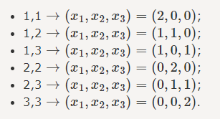
Note that here xi≥0��≥0 are integers and x1+x2+x3=2�1+�2+�3=2. Thus, we can claim that the number of ways we can sample two elements from the set A={1,2,3}�={1,2,3} such that ordering does not matter and repetition is allowed is the same as solutions to the following equation
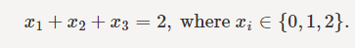
This is an interesting observation and in fact using the same argument we can make the following statement for general k� and n�.

Lemma
The total number of distinct k� samples from an n�-element set such that repetition is allowed and ordering does not matter is the same as the number of distinct solutions to the equation

So far we have seen the number of unordered k�-samples from an n� element set is the same as the number of solutions to the above equation. But how do we find the number of solutions to that equation?

Theorem
The number of distinct solutions to the equation
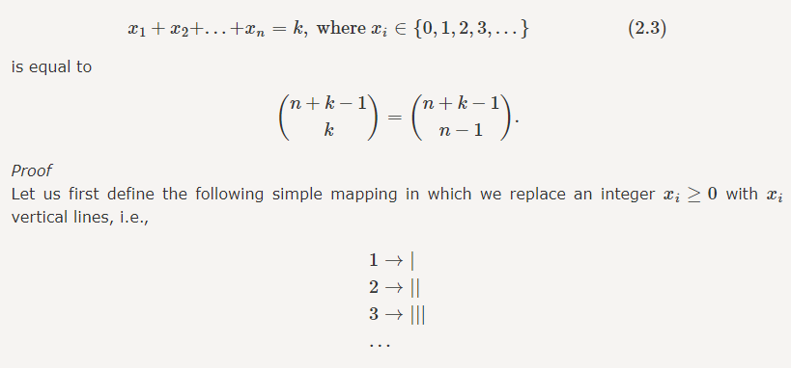

Now suppose we have a solution to the Equation 2.3. We can replace the xi��'s by their equivalent vertical lines. Thus, for example if we have x1+x2+x3+x4=3+0+2+1�1+�2+�3+�4=3+0+2+1, we can equivalently write |||++||+||||++||+|. Thus, we claim that for each solution to the Equation 2.3, we have unique representation using vertical lines ('||') and plus signs ('++'). Indeed, each solution can be represented by k� vertical lines (since the xi�� sum to k�) and n−1�−1 plus signs. Now, this is exactly the same as Example 2.7: how many distinct sequences you can make using k� vertical lines (||) and n−1�−1 plus signs (++)? The answer as we have seen is

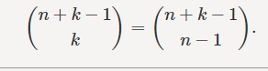

Example
Ten passengers get on an airport shuttle at the airport. The shuttle has a route that includes 55 hotels, and each passenger gets off the shuttle at his/her hotel. The driver records how many passengers leave the shuttle at each hotel. How many different possibilities exist?

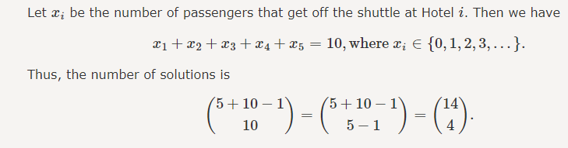

Let's summarize the formulas for the four categories of sampling. Assuming that we have a set with n� elements, and we want to draw k� samples from the set, then the total number of ways we can do this is given by the following table.
